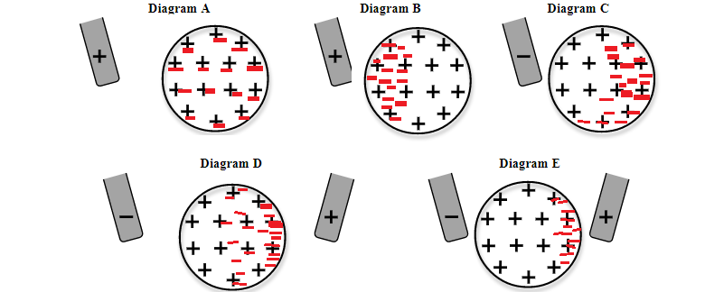Conclusion.

Overall the entire can must be neutral all the time. Since the object is never touched then there is no change of overall charge. However when a negative object is introduced the object is polarized and the electrons get repelled to the opposite side. When a positive object is introduced the object is polarized so electrons get attracted to the side of the positive object on the can. When there is a negative rod and a positive rod on either side the electrons get repelled from one side to the other and is attracted to the side of the positive rod. Finally the closer an object is the stronger the effect.